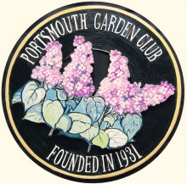
Portsmouth Garden Club
Member Renewal Form

Please fill out this form and mail to Jean Bell, 23 Taft Road, Portsmouth, NH 03801
along with your check for $25.00 made out to the
Portsmouth Garden Club for the club year September 1, through August 31.
All forms are due by May 31st. Thank you.

Name____________________________________________
Address __________________________________________
Phone number _______________Cell number___________
Email_______________________________

Special garden and program interests_______________________________
Please choose a month to be on the Refreshment Committee. We meet from September through May.
Please see page 5 of your Handbook. We don’t need volunteers for December as it is our Holiday Luncheon.
First choice _____________________________Second choice____________________________
No preference ________________________ (I am available any month.)
I WOULD LIKE TO BE ON THE FOLLOWING COMMITTEE(s) (See back for committee choices)
______________________________________________________________________________
The Festival of Trees in not a separate committee. Every member is expected to be involved in a Festival of Trees Year.
The dates for our next festival are November 12, 13, 14 of 2021.
Note: If you have any questions regarding completion of this form, please call
Jean Bell at 603-436-3307 or email to jeanmbell@comcast.net
I give the Portsmouth Garden Club permission to use my physical image and/or my club related
projects/activities to be photographed and/or videotaped.

Signature: ____________________________________________ Date:________________________

